Interlude I

Learning from the writing
8th September 2001

In the three months that have passed since I thought I had completed my thesis, I have discovered that beyond learning through the process of writing, another level of learning was waiting for me – that of learning from the writing. In recent weeks I have been reading and rereading my own text and engaging in lively face-to-face debates and email dialogues with Jack Whitehead, Moira Laidlaw and other “critical friends”. This has enabled me to stand back from the text somewhat as I address the question: What does living my life of inquiry mean for the communication of my learning?

This question has opened up some significant new perspectives on my work. Responding to it encourages me both to embolden my claims about the significance of my thesis and to apply my critical judgement more explicitly to my narratives of inquiry. I understand more now about the particular contribution I am making to an emerging scholarship of inquiry whilst also realising that my original text needs some amendments and additions in order to communicate my learning about living inquiry more effectively.

I outlined some of these changes to the form of the thesis in the Introduction where I speak about “folding the text back on itself”. By placing a chapter on the purposes, scope, epistemology, validity, methodology and position of living inquiry at the front of the thesis (even though it was – and could only have been – written after subsequent chapters) I can now invite you, the reader, to join me as I revisit my narratives of inquiry to trace the emergence of the distinctive standards of judgement and criteria of validity which are articulated in the opening chapter. In this way, I hope to clarify the meanings of these standards, not just linguistically, but as they are embodied in my developing practice (as a man, in loving relationships, as a healer and as an educator). The need for this became quite apparent during a supervision session with Jack on 1st September (2001) when he pointed to a section of the original draft of Living Inquiry (now amended) in which, speaking of a possible “third place” where mythos and logos meet, I said:

I do not want to reduce this mystery to a set of propositional value statements. Jack, it is not my intention to be dismissive of your suggestion to explicate my values but, right now, I would rather honour this mystery than try to explain it.

As I turned the page I could see that I had then summarised my standards of judgement and criteria of validity in a series of twelve, blunt, bullet-pointed, propositional statements. The obvious dissonance between my declared intention and my actual behaviour in listing the statements in this way caused near-hysterical laughter. I could see how, out of the context in which they emerged, this “vulgar” listing of criteria represented a violation of my own aesthetic judgement of my life of inquiry as a work of art. I was reminded again of the quotation from Lyotard that, much earlier, I had referred to when writing Interlude II: The space between:

The artist and the writer, then, are working without rules in order to formulate the rules of what will have been done. (Lyotard 1984 p81)

It would be quite misleading for me to pretend that I constructed my thesis in accordance with a set of pre-established rules. I was only able to synthesise my distinctive standards of judgement and criteria of validity for living inquiry in hindsight. However, I can now return to my narratives of inquiry to trace the emergence of these standards and criteria and clarify their meanings in practice. In doing so, I am conscious of a subtle but important distinction between my living inquiry and Jack’s notion of living theory (Whitehead 1993). In the latter, our embodied values (defined as those human goals for the sake of which we do things) are considered to be the primary source of motivation. Thus, they are assumed to have explanatory power in relation to the nature and direction of our inquiries. I do not deny that such human values play an important part in shaping our lives but, as I say in Chapter Six: Living Inquiry (Reprise), I find myself less guided by concepts of
social values than by the mysterious voice of my soul – intimations, intuitions, insights and a kinaesthetic sense of rightness or “fit”. Where I agree with living theory, and why I think it is important to revisit my narratives of inquiry, is that our distinctive standards of judgement and criteria of validity both emerge from and shape our practice. The dialectic of action research requires another iteration – a further level of reflection – to apply these standards and criteria to my own text.

In order to make the application of my critical judgement quite explicit, and in order to avoid disrupting the flow of the text with excessive and intrusive interpolations, I have decided to append separate commentaries to each of the four narrative chapters: The Men’s Room, Postcards from the Edge, Healing Journeys and Reshaping my Professional Identity. In these commentaries I shall focus on what I am learning from the writing about my life of inquiry and how that relates to the twelve distinctive standards of judgement and criteria of validity outlined in Chapter One: Living Inquiry. It would be tedious and repetitive to address all twelve in each commentary so I will narrow the focus to those that seem most relevant in each case.

Returning now to the particular contribution I am making through this thesis to an emerging scholarship of inquiry, my conversations with Moira Laidlaw have clarified my sense of why I think living inquiry matters so much. I believe that, in living my life of inquiry, I have brought together the personal and the professional, the inner life of the psyche and the outer life of working for good in the world, mythos and logos in ways that speak to the human condition. In celebrating and affirming my life of inquiry, I am celebrating and affirming the lives of each of us. In speaking for myself I am proclaiming my membership of the human race. In telling my particular story there are moments when it touches archetypal themes to which we can all relate.

In Chapter One: Living Inquiry I borrowed the words of psychotherapist and educator Carl Rogers to describe this phenomenon: “When you travel to the unique heart of a person you find yourself in the presence of universal truth.” Rereading my text I have come to think of these narrative epiphanies as the place where ontology,
epistemology and cosmology meet and have coined the term mythic resonance to characterise this quality. This goes beyond making an aesthetically engaged and appreciative response to a story (D'Arcy 1998), it involves seeing oneself present in the story of another and seeing that story present in one’s own life of inquiry. I think we all have such stories to tell and in Healing Journeys, when describing a workshop on storytelling as meaning-making and community-building that I ran at Bath University in March 2000, I offer some examples of this same quality in other people’s stories.

Rereading my own thesis has helped me to a more holistic appreciation of my life of inquiry and encouraged me to share the story of Jumping Mouse as a meta-myth for living inquiry. Although many fragments of stories, poems and images were already woven into the fabric of the text, I wanted something to represent the whole and have interpolated the telling of Jumping Mouse in the context of Healing Journeys, where it belongs – at the very heart of the thesis. It is a telling (to be heard) rather than a text (to be read) because listening opens up a qualitatively different imaginative space, one that I hope will stimulate your connection with this mythic story in a way helps you relate to my own story of living inquiry.

In the past few weeks I have also been able to “read across” my narratives of inquiry, searching for patterns and relationships between them. I experimented with forms of creative representation that might reveal some of these connections and eventually traced the chronological development of each of the four major strands of inquiry over the period 1985 to 2001 using my subjective judgement of the energy I put into each of them. Having drawn and redrawn these lines half a dozen times until satisfied with the result, I combined them in a single multi-coloured graph to see the overall effect. The result was a complex curvilinear pattern, within which I can perceive several phases (recognising that these are personal constructs arising from my own will to meaning).

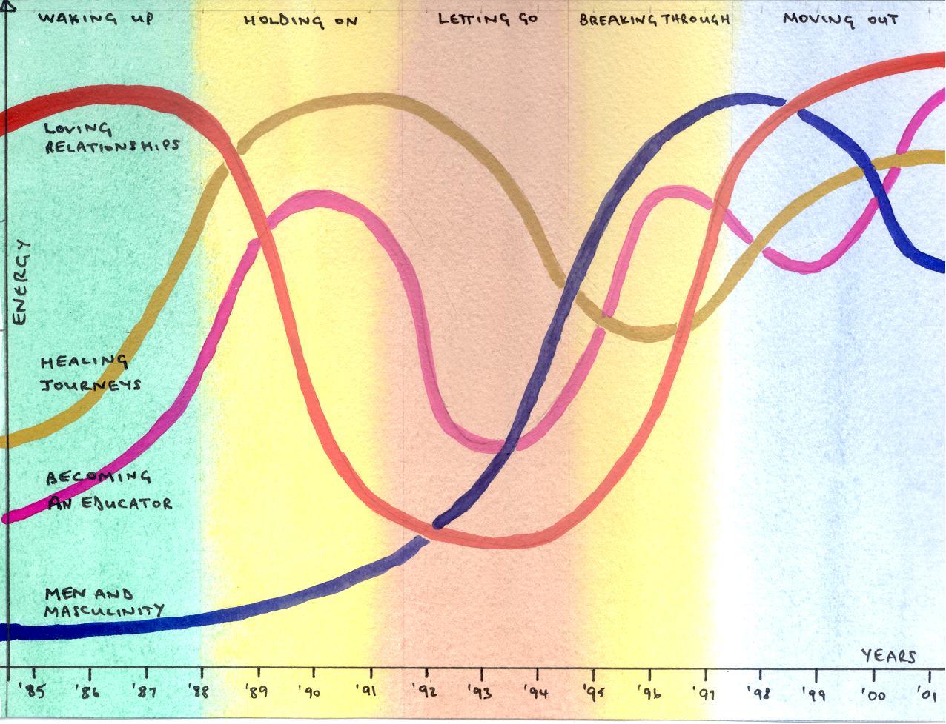
I have labelled these phases intuitively: they reveal to me the reawakening of my inquiring spirit in my mid-thirties (Waking Up) and the way my inquiries into self-healing – through therapy – and my role as an educator sustained me as my marriage descended into misery and despair (Holding On). There followed periods when even they were not enough (Letting Go) and when inquiring into my masculine identity – through men’s work – pulled me through (Breaking Through) to renewed levels of inquiry in other areas including loving relationships, storytelling, educational action research, even writing this PhD (Moving Out).

I do not want to labour this thematic approach or to extend it beyond the point of useful insight, so I include the diagram to show the overall pattern rather than any detailed analysis. Looked at askance and imagined in three dimensions, it is not too difficult to see a rather shaky DNA-like double helix stretching across the page and I like this metaphorical image of inquiry as the stuff of life. Living inquiry indeed.

See – Chapter Six: Living Inquiry (Reprise)
Gregory Bateson makes this point in the concluding dialogue of his book Mind and Nature Bateson, G. (1988). Mind and Nature. New York, Bantam Books.
Quoted in Reason, P. and B. Goodwin (1997). Complexity Theory and Co-operative Inquiry. University of Bath Unpublished Paper.
I mean relate in the sense that educational action researcher Michael Bassey uses the term, in contrast to generalisation, to signify an intuitive recognition of the relevance of something beyond the boundaries of a particular source (which he calls a singularity).

