Introduction

Ending and Beginning
14th October 2001 (amended 5th May 2002)

Only now, three months after putting what I thought would be the final full stop at the end of Last Words has the form of the thesis I want to present emerged fully. So I have come full circle back to the beginning to suggest an appropriate perspective from which to frame it and provide some clear signposts to help you find your way around. I shall try to do so as economically as possible, without anticipating or rehearsing the detailed argument of the text itself.

Let me begin, therefore, with the guiding metaphor that occurred to me as I started writing the thesis. I visualised the thesis I wanted to write as a house with several rooms, opening onto a central atrium in the fashion of a Roman villa. They are thus separate and connected, enabling one to wander between them at will. The villa has a portico, the Prelude, through which you enter and another, Police Stories through which you leave.

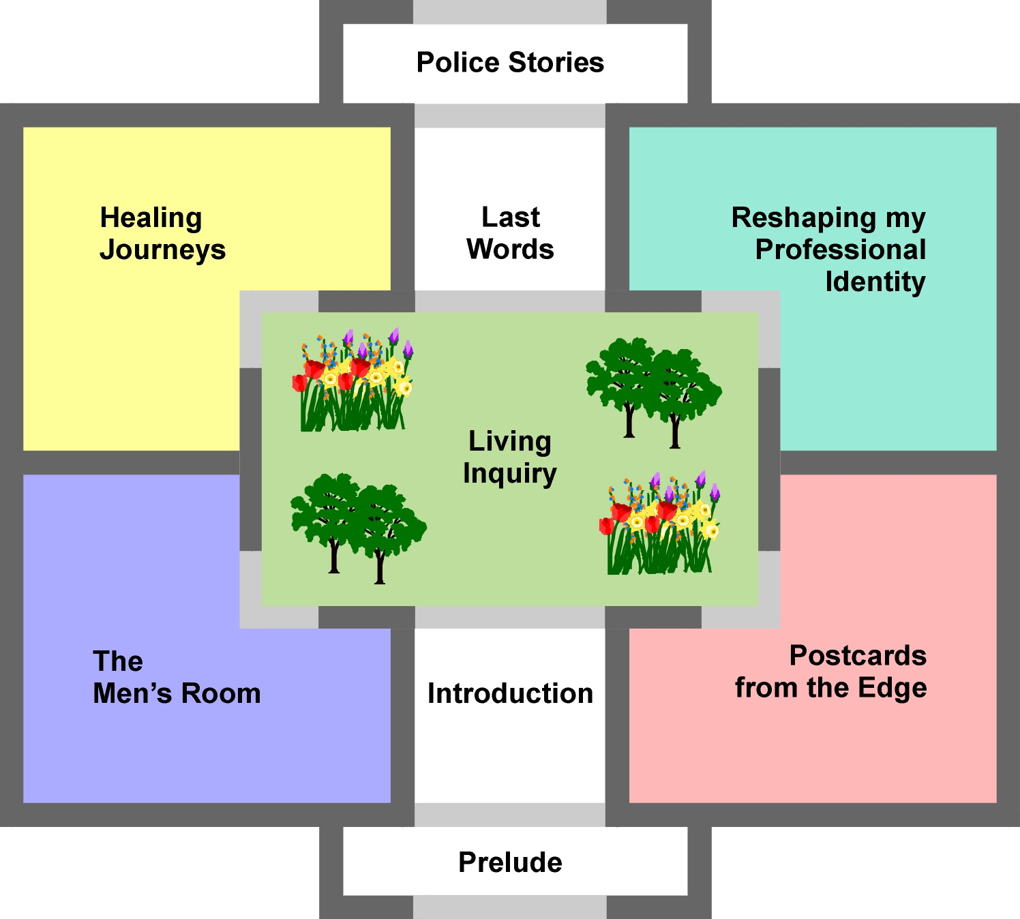

The garden at the heart of the edifice represents Living Inquiry – my exploration of the nature of my contribution to an emerging scholarship of inquiry -– and around it are arranged four rooms representing the extended inquiries into my interwoven personal and professional practice: The Men’s Room, Postcards from the Edge, Healing Journeys, and Reshaping my Professional Identity. I would like you to imagine that the whole structure is translucent, enabling you to see in, out and across all the rooms from anywhere in the building. In this way too, it is permeable to the light of the world, open to its influence rather than cut-off and self-contained.

I always intended to write these narratives of my inquiries before exploring the nature of my living inquiry in more depth and I did not originally envisage the reflective Interludes interspersed between the main chapters. Staying with the metaphor, I naively thought that I could go round all the rooms before stepping in to the garden and I found (unsurprisingly in hindsight) that I was constantly drawn into the demands and delights of inquiring about inquiry.

As an aid to writing, the metaphor served me well but – like all metaphors – it has its limitations. A building, even one with a garden, is static and, in order to communicate the meanings of my thesis to you, the reader, a more dynamic form is called for. I had originally intended to present all sections of the text (with the exception of this Introduction and Police Stories) in the order in which they were written. This seemed important to maintain the integrity of my writing-as-inquiry and to expose the gradual deepening of my understanding through successive phases of writing and reflection. There is a certain logic to this approach: after all, I could not have written Living Inquiry without the learning and insights that resulted from writing the four narratives of inquiry represented by The Men’s Room, Postcards from the Edge, Healing Journeys, and Reshaping my Professional Identity. Yet, I am also conscious that, as a reader, you may need the arguments, conclusions and theoretical groundings of Living Inquiry “up front” in order to engage fully with the narrative chapters.

The original form of the text was a chronological record of my writing-as-inquiry (it was never a chronological record of my life-as-inquiry). But I want it to be more than that: as an educator, I want my text to be a pedagogical communication too. Talking about this recently with my supervisor, Jack Whitehead, it was clear that this meant that I needed to reorder the text, with Living Inquiry as the opening chapter. What actually arose was the idea of reflexively “folding the text back on itself” – critically commenting on each of the four narrative chapters in the light of the standards of judgement and practice emerging in the course of their creation but only articulated subsequently in Living Inquiry.

To achieve this Moebius-strip-like form within the limitations of a printed text you will find that Living Inquiry features in both the opening and closing chapters of the thesis. Chapter One: Living Inquiry contains most of the material from the original final chapter including the distinctive standards of judgement and criteria of validity that I use to critically evaluate my inquiry practice in the subsequent narrative chapters. Chapter Six: Living Inquiry (Reprise) revisits some questions of validity, authenticity and rigour through imaginary dialogues with Peter Reason, Judi Marshall and Jack Whitehead, my tutors at CARPP. It closes with a final reflection on the whole thesis, Last Words.

This structure enables multiple readings of the text – learning through the writing and learning from the writing. I hope that, having read the four narrative chapters, you might want to read Chapter One: Living Inquiry again with a richer, deeper understanding of how it relates to the underlying and interrelated strands of inquiry.

The metaphors of the villa and the Moebius strip give some indication of the relationships between the various elements of the thesis but say little about its quality and depth or about the dynamics giving rise to its overall form and style. These too, call for some explanation.

First, and foremost, I am passionately committed to developing a holistic form of inquiry, one that takes seriously the notion that living one’s life as inquiry matters and that, if that inquiry is sufficiently deep and rigorous (with its own distinctive and appropriate standards of judgement and practice and criteria of validity to substantiate claims to knowledge and meaning) it may also claim a legitimate place in the academy as a contribution to scholarship.

This commitment requires me to transcend conventional boundaries between the personal and the professional and to work with “real” issues about significant aspects of my life. Rather than restrict myself to my professional practice as an educator, I have also traced the paths of extended inquiries into my identity as a man, my conduct in loving relationships (including separation and divorce) and my long search for self-healing. To exclude any of them would be to deny a crucial aspect of my life of inquiry.

Although I touch on wider issues and connections, the text is essentially an account of my own journeys of inquiry and of how – through writing the thesis – I come to my own scholarship of living inquiry. Thus, I engage with a wide range of other people’s ideas “authentically” as they influence my inquiries rather than conduct extensive literature reviews in particular subject areas. In taking this approach, I am consciously eschewing one of the conventional ways of demonstrating the “depth” of my research. Given the focus of my thesis on living life as inquiry, I suggest that the extent of experiential grounding, the richness of narrative and the insightfulness and candour of my writing are more appropriate indicators of quality and depth.

A second major influence has been my commitment to inquire through the process of writing the thesis. I want to learn, to be surprised by what I write, not merely “write down” what I already know or “write up” a collection of data. To a considerable degree, I have held true to this intention, learning much through the act of writing and through the periods of deep reflection that have accompanied it. The thesis is therefore not merely about action research. Rather, the thesis itself enacts a process of action research.

Thus, as you read the narratives of my inquiries into my practice as a man, in loving relationships, in search of healing and as an educator – presented in the same order in which they were written – I invite you to notice how I gradually come to realise my scholarship of living inquiry as I develop my capacity to deepen the dialogue between the originality of my authentic inquiry process and the rigorous application of my critical judgement.

As I completed each major chapter, I naturally paused, reflecting upon what I had written and engaging with others (notably Jack Whitehead, my supervisor) in dialogue about it, feeding my emerging understanding of my living inquiry and constantly asking what overarching question the text was “seeking” to answer. To make this cyclical process quite explicit, I have dated key pieces of reflective writing such as the Prelude and the various Interludes.

Responding to Jack’s questioning and to the challenges of other colleagues in the CARPP postgraduate community has powerfully stimulated my thinking and influenced the development of the thesis in recognition of which, I present some of the most significant of them in the text. These dialogues have been an integral part of my inquiry, enabling me to clarify and articulate the qualities and practices of my inquiry process, relating it to other people’s ideas without subsuming its distinctive form within their conceptual frameworks.

I touch upon methodological and epistemological issues as they arise but reserve a detailed consideration of these issues for Living Inquiry. As I indicated earlier, writing the thesis was the process by which I learned about the purposes, scope, epistemology, validity, methodology and position of my inquiry process. I needed to write the narratives of my extended inquiries in order to understand and articulate the principles behind them. That has been a primary purpose of my research and to pretend otherwise by claiming adherence to a predefined methodology would be misleading if not downright dishonest. Therefore, I ask you to notice the emergence and development of these dimensions as they arise naturally in the text culminating in a detailed exploration of the qualities and practices of my inquiry process in Living Inquiry.

Third, and as a consequence of the above, the text and my understanding of the question it seeks to answer changed together over time in a dialectical relationship, each challenging and informing the other. At first, I assumed that the overarching question would be the one I had asked in my MPhil/PhD transfer paper: How can I live my life with authenticity, integrity and joy and help others by sharing the story of my learning in living my life as inquiry? This heuristic served me well as I wrote The Men’s Room and Postcards from the Edge. Indeed, towards the end of both chapters I tell such stories without commentary or interpretation, believing that they speak for themselves and in the hope that they might stimulate you, the reader, to connect with your own self-stories and your own “will to meaning”.

However, as I anticipated writing Healing Journeys, the emphasis shifted from simply telling my stories to wondering how I could help other people tell theirs, and I realised that the nature of the question needed to change accordingly. In the third interlude, Writing an abstract, you can see how – borrowing its formulation from Heidegger – my question became: What is it to ask what this thing –“ Living Inquiry” – is? It seemed to me that this implicit invitation for others to join me in exploring living inquiry from the inside, so to speak, was more inclusive than my original question and, though challenged by Jack Whitehead and other colleagues, it too served me well enough as I wrote Healing Journeys.

At that point the question changed again as I realised that what I was really asking was much simpler and more profound than Heidegger’s formulation allowed. Perhaps too I needed time to find the courage to express my fundamental research question in my own words. What fascinated (and still fascinates) me is: What does it mean for me to live my life as inquiry? Asking this explicit question enabled me to move confidently into writing Reshaping my Professional Identity and then to explore the qualities and practices of my inquiry process in Living Inquiry. At about the same time as the overarching question emerged in this form, I also surfaced the image of “unlatching the gate” as a metaphor for the kind of life-affirming learning that, as an educator, it is my purpose in life to encourage and support in others and to sustain in myself.

This question held me throughout the final stages of writing a complete draft of my thesis and I still think it best reflects the substance of its intent. However, thinking about how I want to communicate my learning with the reader of this text has
prompted a further challenge so that the question I am addressing now as I prepare the final document for submission is: What does living my life of inquiry mean for the communication of my learning? In part this thesis traces how, through living my life of inquiry, my professional identity has shifted from police officer to educator. As an educator, I want to do more than present a record of my inquiry: I want my notion of
Living Inquiry to influence the social formation of the Academy. I must therefore think carefully about how best to communicate my learning to practitioners and scholars alike and structure my thesis accordingly.

The conjunction of an image and a statement in the title of the thesis reflects the fourth significant dynamic affecting its form and style – my concern to do justice to all my ways of knowing and, in particular, to acknowledge and honour both mythos (creative intuition) and logos (conscious structuring) equally. In doing so, I am consciously challenging what I take to be the implicit valorisation of logo-centric forms of knowledge and sense-making in the Academy by giving mytho-centric forms an equal status. Through a variety of presentational forms, I offer a text that enacts (as well as describes) a complex and multiple epistemology. Thus, I both “show” and “tell” the emotional, aesthetic and spiritual dimensions of my inquiries with rich and evocative stories, myth, poetry, the spoken word and visual images. I also engage critically with my lived experience, with narratives of my inquiries and with the ideas of others, to claim academic legitimacy for living life as inquiry and to create my own distinctive form of living inquiry as a contribution to an emerging scholarship of inquiry.

Last, writing the thesis has been a rite of passage from being an inquirer to becoming a researcher. I think this is evident in the growing quality and confidence of the writing as I come to understand and integrate other people’s ideas with my own reflections upon lived experience and as I deepen the complex, dialectical interplay between authenticity and rigour in the text. In Chapter Five: Reshaping my Professional Identity, for example, you will see how I rigorously re-examine an article accepted for publication to ensure that its claims are grounded in data and supported by evidence. I want the variations and improvements over time in the quality and texture of the writing-as-inquiry to be evident to you as an integral part of the thesis and therefore I have resisted the temptation to “smooth” it out retrospectively by extensive editing (other than to ensure that the meaning is clear and the choices I have made in shaping the text are explicit).

At the end of this long journey of exploration, I find my own voice as a researcher and – having grappled with these complexities – am able to respond simply and clearly to my own question: What does it mean for me to live my life as inquiry?

It means, to live my life as fully as I can, from an optimistic stance, and choosing to act as if I matter, as if each of us matters, as if we can make a difference in the world… It means widening the orbit of our lives, becoming concerned with bigger questions without losing sight of the smaller ones… [Like the orange tree that carries] ripe fruit, blossom and buds… some parts of me have ripened, some are gone, but I also have new growth and I’m blossoming too – as a man, a father, a lover, a healer, an educator, as a researcher, a writer and storyteller.

Having provided some indications of the form and style of the thesis, it may be useful to give some clues to the content of each chapter, if not as a route map at least to give you the lay of the land.

Prelude: Go I know not whither, bring back I know not what
Written between January and May 2000, I ask myself why I would want to write a PhD thesis at all and conclude that to do so would be a tremendous act of self affirmation. After being stuck for several months I invoke the sacred energy of Hermes to inspire and guide me as I write. I explore the difference between “beginning” and “making a start”. I decide to make a start by addressing three vital questions: What sort of inquirer am I? What inquiries do I want to write about? How do I want to write about my inquiries?

Introduction: Ending and Beginning
In this section, which was the last to be written and which you are reading now, I come full circle back to the beginning to frame the thesis in terms of its underlying dynamics. I sketch the contents of each section and offer two very different visual metaphors to suggest how the constituent parts come together to form a whole – the gestalt that represents my living inquiry – a Roman villa and a Moebius strip. My intention is to communicate the rationale of the thesis and of its concommittant style and form.

Chapter One: Living Inquiry
In this chapter I draw upon the subsequent narratives of my inquiries and critically engage with ideas from a wide range of literatures to theorise sparingly about living inquiry. As the chapter unfolds, my growing understanding of the qualities and practices of my inquiry process enables me to claim legitimacy for living inquiry in its own terms. I examine in detail, the purposes, scope, epistemology, validity, methodology and position of my approach as a contribution to an emerging scholarship of inquiry. I pay particular attention to the implications of treating mythos and logos as “equal partners” and identify twelve putative attributes of my living inquiry which are offered as distinctive standards by which its quality can be judged:

Breadth and Depth Self-generated Creativity
Duration Reflection and Reflexivity
Experiential Grounding Relatability
Passion and Reason Textual Quality
Courage Epistemological Balance
Change and Transformation Critical Judgement

Interlude I: Learning from the writing
In this section I explore what I have learned about the nature of my thesis (and how I want to communicate my learning) since completing the first draft. Having been committed to learn through the process of writing (writing-as-inquiry) I discover that there is another phase in which, in dialogue with others, I learn from the writing. As an educator, I realise that I want to do more than present a record of my inquiry: I want to influence the social formation of the Academy. I explain how, as a result of this, I “fold the text back on itself” and interpolate an additional critical commentary in each of the four narrative chapters to show how the twelve standards of judgement and practice articulated in Living Inquiry emerge in the course of my inquiry practice.

Chapter Two: The Men’s Room
The first of my narratives of inquiry, a form of “auto-ethnography”, a “messy text” in which I offer a collection of stories, poems and narratives connected with a decade of inquiry into men, masculinity and men’s development. I focus upon my own experience of ritual events, ongoing men’s support groups, relevant literature and collaborative inquiries into men’s development in organisations (drawing on several published papers and presentations to conferences). The chapter concludes with an open letter to my close friend Chris that explores and celebrates our relationship as “brothers in arms”.

Interlude II: The space between
Having written The Men’s Room, I engage in dialogue with Jack Whitehead, my supervisor about the text. We address four questions: What question(s) is the text seeking to answer? What claims to knowledge am I making? By what standards should the text be judged? How is this inquiry action research? I deepen my understanding of these issues and go on to consider objections to the “personal-confessional” genre of research as well as the need to place some limits on disclosure to avoid causing harm to those I love (and to acknowledge their right to a degree of privacy).

Chapter Three: Postcards from the Edge
In this chapter I turn to the struggle to find happiness in loving relationships beginning with the effect of my father’s early death and moving to the events surrounding my recent separation and divorce. I consider the tension between living and telling and seek to “deftly integrate” them in my narratives. I explore the healing power of fiction and present stories, poetry and visual images as well as more conventional prose. I treat my experiences as conscious acts of inquiry and “interrogate” the text to identify and articulate some of the qualities and practices of my first-person inquiry process. It closes with a piece called Into the Fire, a mosaic revealing some of the “rediscovery of connection” with my ex-wife and children.

Interlude III: Writing an Abstract
After sending the previous chapter to Jack Whitehead he invites me (or perhaps challenges me) to produce an abstract of the thesis. Initially, I resist his invitation and then I attempt a first draft. I present it for consideration to a validation group of my colleagues at a CARPP workshop where it is thought to be over-long, more of a summary than an abstract. The process advances my understanding of my emerging thesis and I articulate a new overarching question: What is it to ask what this thing – “Living Inquiry” – is? Subsequently the abstract undergoes many revisions before, ironically, my examiners at the viva voce on 22nd March 2002 declare their preference for the original version and ask me to reinstate it with some amendments and additions at the head of the thesis where it now stands.

Chapter Four: Healing Journeys
Here I explore ontological issues and the nature of my inquiring self. I draw on an old Indian proverb to suggest that development of the self requires us to pay attention to four aspects of being: physical, emotional, mental and spiritual and illustrate some of the ways I have addressed these. I briefly consider post-modern notions of the “saturated self” which I reject in favour of “narrative identity”, a self “born in stories” and I present one such story: The man who lived as a king as a real-life example of self-renewal after “narrative wreckage”. I develop the idea of “transformative spaces” as containers for transformational learning - drawing on notions of thymos, “voice”, Gestalt psychology and experiences of creating ritual spaces to suggest some of the conditions that promote such learning. I go on to inquire into my practice as a storyteller and educator, through the medium of a storytelling workshop I ran at Bath University in March 2000. At the heart of this chapter, I tell the story of Jumping Mouse as a meta-myth for my life of inquiry and explore the ontological significance of such archetypal stories.

Interlude IV: The point of no return
I consider the implications of offering up my thesis for examination and face my “doubts” about whether I will be able to make my emerging ideas about living inquiry intelligible to others. I resist the temptation to adopt Jack Whitehead’s living (educational) theory framework, preferring to trust my own originality of mind and critical judgement. I introduce the notion of a “hunter-gatherer” epistemology and present the image of a gate with its attendant metaphor of “unlatching the gate” as connotative of my purpose as an educator (and inquirer).

Chapter Five: Reshaping my Professional Identity
I begin by reformulating my overarching inquiry question as: What does it mean for me to live my life as inquiry? I then adopt a narrative basis for reshaping my professional identity from police office to educator and offer a sketch map of my changing “professional knowledge landscape”. I relate some “travellers tales” of my exploration of this landscape since 1988, focusing on three major police educational programmes for whose design and delivery I have been responsible. I acknowledge the influence of Jack Whitehead’s living (educational) theory framework on my understanding of my professional development but subsume it within my notion of living inquiry.

I look at the purposes, methods and outcomes of the three educational programmes and show how they represent a gradual move towards congruence with my “espoused values” about people and education. I frequently refer readers to Police Stories to provide the personal and professional context for this work. The chapter includes the text of an article on the use of collaborative inquiry in a hierarchical organisation that has been accepted for publication in December 2001 in a special edition of the journal Systemic Practice and Action Research. The article is rigorously re-examined to ensure that its claims are grounded in data and supported by evidence.

Interlude V: Turning for home
I recognise that it is time to build upon the preceding narratives of inquiry and shift the emphasis from “showing” to “telling” by subjecting them to a deeper level of reflection and theorising to position the research conceptually and in relation to the literature. I am moved by Jack Whitehead’s opinion that my work will make a substantial contribution to self-study action research and I reaffirm my intention to articulate my own distinctive form of living inquiry. I express the hope that, having read the four narrative chapters, you might want to reread Chapter One: Living Inquiry (which originally followed this Interlude) with a richer, deeper understanding of how it relates to the underlying and interrelated strands of inquiry before moving on to the final chapter.

Chapter Six: Living Inquiry (Reprise)
Here, for the reasons outlined earlier in this Introduction, I return to a wider consideration of living inquiry. The chapter revisits questions of validity, authenticity and rigour through imaginary dialogues with Peter Reason, Judi Marshall and Jack Whitehead, my tutors at CARPP.

In the second section I respond to the request, made by my examiners Professor Helen Simons and Doctor Donna Ladkin, to make several minor amendments to the thesis by articulating six principles that inform my continuing life of inquiry and by showing how my scholarship of living inquiry both draws upon and pushes against the edges of a number of established fields of inquiry to make an original contribution to an emerging scholarship of inquiry.

The chapter closes with a final reflection on the whole thesis, Last Words in which as the author of this text and as the author of my life, I find my own voice as a researcher to respond simply and directly to the question: What does it mean for me to live my life as inquiry?

Note: Ethical considerations
A brief consideration of some ethical dilemmas in participative and self-study research: I explain the approach taken in the thesis to naming colleagues, friends and family members in the light of published ethical principles and guidelines for the protection of human research subjects.

Appendix A: Police Stories
Written in 1998 and updated in 2001, this is both a narrative of and a reflection upon my near thirty-year police career. It provides an important personal and professional backdrop to my other inquiries. It has been on the Internet for several years (www.actionresearch.net) and attracted comment from a number of police and non-police readers, ranging from anger and disbelief to rueful familiarity. I refer to it frequently throughout the thesis, notably in Chapter Five: Reshaping my Professional Identity.

Appendix B: The Future for Men at Work
This appendix is a transcript of the recording of my presentation to the Men and Women: Working Together for a Change conference, which is included in Chapter Two: The Men’s Room.

Appendix C: Jumping Mouse
This appendix is a transcript of the recording of my telling of Jumping Mouse, which is included in Chapter Four: Healing Journeys.

These are difficult and dangerous times. I am writing these words five weeks after the dreadful attacks on New York and Washington: the military campaign against the Taliban regime in Afghanistan is entering its second week, there are reported cases of anthrax in the United States and further terrorist reprisals are threatened. In such circumstances I have had to ask myself whether this exploration of living inquiry still matters. My answer is not glib and has taken much soul-searching: I believe that living a life of inquiry matters more than ever. Living inquiry is the antithesis both of fundamentalism (by which I mean the unthinking acceptance of dogma and the surrender of personal responsibility and judgement) and of complacency (by which I mean a lazy and arrogant assumption of superiority). Striving to become more aware of oneself and to become more open to “other” have never been more important than now as the world stands once more on the brink of a terrible clash of civilisations.

So I am completing this thesis conscious both of my smallness in the world and of the potential of one person’s story of living inquiry to be a force for good. As a storyteller, I know that it is the personal and the particular – not abstract generalisations – which enable us to relate to each other and to connect with the universal. Each of us, in telling the story of our life of inquiry, tells the story of Every(wo)man. You will find that mine is a personal and passionate text that, I believe, speaks to the human condition (perhaps because it makes no claim to speak for another) and sometimes transcends the boundaries of academic writing to achieve “mythic resonance” – where ontology, epistemology and cosmology meet.
All that remains in this Introduction is to welcome you to my thesis. I hope that you find it interesting, enjoyable and worthwhile, that reading it evokes some of your self-stories and engages your own “will to meaning”, that it encourages you to honour your own life of inquiry, and that it persuades you of the value and academic legitimacy of my particular form of living inquiry.

The Moebius strip is a three-dimensional topographical form with only one edge and one surface. It can be constructed by putting a half-twist in a strip of paper and gluing the ends together. It is then possible to trace a single line on its surface, which ends up where it started.
Driftwood and Dogmeat – of my close and loving friendship with another man, and Into the fire – of a gradual reconnection with my ex-wife and children after separation and divorce
Extracted from Last Words in Chapter Six: Living Inquiry (Reprise)
I am thinking here of this universal quality in the 15th Century English morality play Everyman. An excellent version can be found at www.fordham.edu/halsall/basis/everyman.html.

