Endpiece

In these final words I intend to give the readers the sense of being brought to an ending/answer so far and, consistent with the spiral nature of the action research process (McNiff, 1995), share some potential next steps. As Michael Bassey (1995) says in his “endpiece”,

…there are three ways to create education: playing hunches, repeating what has been done before and the third way: by creating education by asking questions and searching for evidence; … by challenging and developing one’s own personal theories of education by asking ‘how do I improve my practice? (p.139).

It seems fitting at this point to answer the question, “What have I learned?”

I have learned to create education (Bassey, 1995) and educational theory learning and sharing in collaboration with others. In this sense this thesis is our story, our education; it is a process in which my friends, family and professional colleagues have been partners and co-researchers. I have contributed to a discipline of educational inquiry-“living educational theory”, a scholarship of inquiry (Whitehead. 1999) and a new epistemology of scholarship (Schön, 1995). I am fortunate that I have escaped the feelings of failure so vividly described by Grant and Graue (1999) and Clark (1997) in that I have evidence that I have had an influence in improving education and have given voice to the practitioner-researchers in my school system. Having said that, I know that there is more to do.

I have learned to make a contribution to the academic and professional knowledge-base of education as a practitioner-scholar in the systematic way I transform my embodied educational values into educational standards of practice and judgement in the creation of my living educational theory (Whitehead, 1989, 1993, 1999). I have demonstrated how these values and standards can be used critically both to test the validity of my knowledge-claims and to be a powerful motivator in my living educational inquiry. My values and standards are defined in terms of valuing the other in my professional practice, building a culture of inquiry, reflection and scholarship and creating knowledge. Understanding my values as standards of practice and judgment is disturbing and fun (Marshall, 1999).

I have learned that the process of building a culture of inquiry, reflection and scholarship involves changing policies, procedures and practices in my educational system as well as much personal commitment to a vision. But that it can be done - one individual at a time (Howey & Knill-Griesser, 2002). That change emerges in a context of creativity (Csikszentmihalyi, 2001, p.116-124), on broken fronts and, while overcoming obstacles and distractions, moves forward at a staggered pace. I have learned as well that it takes time – it is now seven years since the first group started in the Brant Board. Through contributing to building communities and networks, I have learned to encourage and provide sustained support for the creation of the systematized knowledge that Catherine Snow (2001) is searching to find (Delong, 2001b).

I have learned that in the process of acting, reflecting, writing and sharing my learning in public fora, I found my own voice. When I examine my earlier writing (1996-2000), it is lacking the confidence and voice of the scholar that I have become. My writing, as part of my educative discourse, is one of the ways in which I give a form to my life. In forming my life, as a postmodern writer, I am working without rules in order to formulate the rule of what has already been done (Lyotard, 1986).

I have learned that that the professional development of each teacher rests in their own knowledge-creating capacities as they examine their own practice in helping their students to improve their learning. When teachers and administrators experience that capacity in themselves, it is transformatory and they feel that they are truly professional educators (Black, 2001; Christie, 2001; Davis, 2001; Dowds, 2001; Gath, 2001; Kline, 2001; Knill-Griesser, 2001; McDonald, K, 2001; McDonald, M., 2001; Ogilvie, 2001; Sallewsky, 2001; Senko, 2001; Stewart, 2001; Suderman-Gladwell, 2001; White, 2001; Delong, 2001b). That process of partnering with a university fulfilled what Anderson and Herr (1999) had in mind but the path was rocky and demanding. I will try again.

When Julie White presented her research (White, 2001b) to the twenty members of Planning Council on April 10, 2002, the group was mesmerized by her passion and confidence. She said,

Aside from being able to improve specific aspects of my practice through engagement in action research (student writing and math literacy), I have improved my ability to self-assess. This is probably the most valuable tool I have gained through this process. While writing this speech, I had the opportunity to further reflect on the claims that I made in my article on improving student writing in “Passion in Professional Practice” (Delong, 2001b). I found that parts of my report could have used further evidence to support my claims. This come with experience, and the more I engage in the action research process, the better I feel I am getting at self-assessment (White, 2002).

That speech of Julie’s was videotaped and will be part of a CD-ROM for professional development in Grand Erie. I am still learning new ways to support teachers and in 2002-2005, one of three goals that the program support staff in Grand Erie has planned is to enhance the capacities of Grand Erie staff to conduct inquiry and make data-based decisions (Delong, 2002).

I have learned that the academic literature informs my thinking and practice when I am looking to validate my theorizing but for me there is no model of educational leadership (Stoll & Fink, 1996). I can answer my question through the mediation of my creativity and critical judgement in an appreciative engaged response (D’Arcy, 1998) with an idea. My inquiry, ‘How do I improve what I am doing?’ includes an action research process where I integrate the narratives and theories of others into my evaluations and understandings of my own actions. I integrate the ideas of others into my understanding in an attempt to link the local with the global in an attempt to continuously overcome the limitations in what I might be missing. In the creative flow (Csikszentmihalyi, 1990) to my learning, the research of others is only influential as I creatively appropriate it with specific people in specific contexts and especially in dialogue with others. In this flow I am always engaged in moving forward in practice with an inquiring mind, engaging with conceptual ideas and then transferring them into my own practice.

I have learned that I have increased my influence by allowing people in my world to see how much I care for them and openly articulating my faith in their capacities. Part of that influence is as a female leader. I learned that my ontology is relational. My methodology, my epistemology, my ontology is very much dialogic, dialectic and collaborative. Most of my writing, research and daily practice is in collaboration, much like what Heron & Reason (1999) describe as cooperative inquiry. Like me, many of the critical mass (Moffatt, 2001) of teacher researchers in the Grand Erie District School Board and in the world have struggled to find a method of researching my practice that provided “methodological inventiveness” (Dadds & Hart, 2001). I see my heuristic relationship with the inquiries of Greg, Kim, Cheryl, Heather, Julie and Marion in relation to the community helping to enhance the value and validity of my own research and productive life in education. I experience a reciprocal relationship in my response to their ideas, values, and educational standards of judgment, thinking and research.

I have learned (contrary to some views of power and privilege (Noffke, 1997)), that I can use my power in positive ways to improve the capacity of systems to support teachers and administrators to improve learning for students. My value and standard of practice and judgment of valuing the other in professional practice has inspired others’ faith in themselves and encouraged them to research their practice in order to improve their lives and the lives of students. You have had such a positive impact on my life... I mean both my professional life and my personal life. You helped me discover a part of myself that had been hidden until I did my action research project for my Masters (Kine, M., e-mail April 15th, 2002).

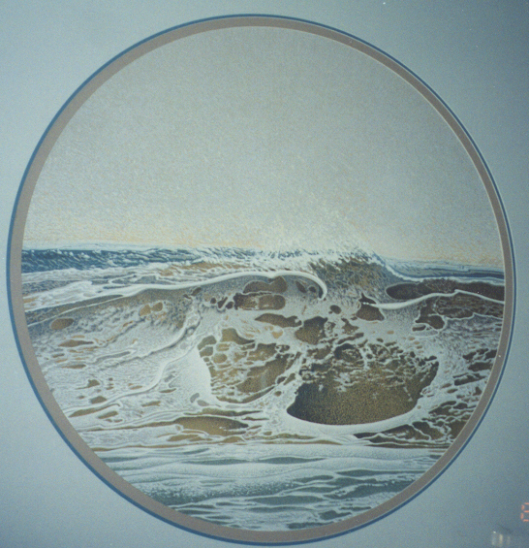I have learned that the image of the mammoth wave has helped me see the rhythm of my life and work. As with the wave, my thesis has rolled and crashed and folded back on itself many times over and carries ideas forth and then back in a steady flow of creation (Csikszentmihalyi, 1990). At times the waves have come crashing down on me with a weight that I thought would drown me and at others have lifted me with a spiritual energy. As with the other photos in the thesis, it carries deep, varied and complex meanings for me.
‘Winter Breaker’ by Ken Bolt, 1991, Studio Proof 1/1

These are interesting times in which to be an educational leader. I have matured personally and professionally, and am now able more to understand the importance of the research in which I am engaged. My research has helped me improve, be accountable for my actions, and ‘shape a professional identity’ (Connelly and Clandinin, 1999). I am fortunate to work with many talented and caring people – staff, students, parents and community members. The growing strength of the action research movement in my board and in the province and its capacity to improve student learning sustains my commitment to its potential. I believe that my research is contributing to the development of insider educational theory. I intend to encourage others to produce their accounts of practice to show how my influence has inspired them to exercise their influence in the lives of others for personal-social benefit. If our aim as educators is to create a world better than the one we currently live in through education, and if we feel we are in positions of influence to do so, we need to support the development of the kind of practical theory in action that will show our practices and also explain the justifications we give for what we are doing. For me, educational administration and leadership are educative, and I hope that I am contributing to a theory of education that will show that educational reality.

Iterative patterns of influence are evident throughout my story. I show how I was influenced by Jack, and how he encouraged me to discover and develop my potential for influence in the lives of those in my care. In turn, I have encouraged the people for whom I am responsible to do the same. In turn, we hope, the children who are the focus of the educational system will find the capacity themselves to become reflective and consider their responsibility in developing a social order in which their children will be happy to live.

I am hoping that my research has met Bassey’s (1995) three prime indicators of quality: adventurousness in the choice of topic, elegance in the process of enquiry, and worthwhileness of the product. (p. 140). These are values I hold in my life as well as my work. At this point in the spring of 2002, I struggle with finding closure and with the balance and congruence between my methodology, ontology and epistemology. I know the path to improvement is never complete. So this represents merely a point along the way. A way I hope I have shared with integrity, elegance and grace.

I feel at ease with the pleasure, beauty and responsibility of my thesis, of the scholarship and contribution to educational knowledge. While I did it for me, to become a better person, I hope that it will be influential with others. I wish to give the last words to my daughter, Shannon:

I think the thing I love about my mom is that she’s genuine in all that she does and in who she is and in who she wants me to be. The thing that struck me most when my mom and I were talking about her thesis was how animated she was about hoping her paper wouldn’t just be good, or that it’s a pretty great accomplishment but that it would be useful to education. That it could make her a better educator and be used as an instrument to help other interested educators also succeed in an area she deems important (Foerter, 1999).

